TECHNICAL STACK

**TECHNICAL ARCHITECTURE**

**Technical architecture**

*Deep learning* is a type of ML that can determine for itself whether its predictions are accurate. It also uses algorithms to analyze data, but it does so on a larger scale than ML.

Deep learning uses artificial neural networks, which consist of multiple layers of algorithms. Each layer looks at the incoming data, performs its own specialized analysis, and produces an output that other layers can understand. This output is then passed to the next layer, where a different algorithm does its own analysis, and so on.

With many layers in each neural network-and sometimes using multiple neural networks-a machine can learn through its own

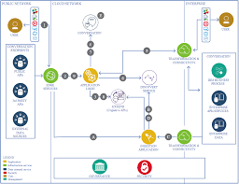

requires much more data and much more computing power than ML.

* [Deep learning versus machine learning](https://learn.microsoft.com/en-us/azure/machine-learning/concept-deep-learning-vs-machine-learning)
* [Distributed training of deep learning models on Azure](https://learn.microsoft.com/en-us/azure/architecture/reference-architectures/ai/training-deep-learning)
* [Batch scoring of deep learning models on Azure](https://learn.microsoft.com/en-us/azure/architecture/reference-architectures/ai/batch-scoring-deep-learning)
* [Training of Python scikit-learn and deep learning models on Azure](https://learn.microsoft.com/en-us/azure/architecture/example-scenario/ai/training-python-models)
* [Real-time scoring of Python scikit-learn and deep learning models on Azure](https://learn.microsoft.com/en-us/azure/architecture/reference-architectures/ai/real-time-scoring-machine-learning-models)

The promise of the metaverse, this new type of three-dimensional and immersive digital space, is proving to become more and more appealing to architects eager to explore the new realm of virtual creations. As it currently stands, the metaverse does not have a singular definition but is composed of many narratives and explorations. This unknown land is however fruitful ground for architects, who have to opportunity to shape not only the new environment but also the experiences of future users. The [SOLIDS](https://www.solids.live/?utm_medium=website&utm_source=archdaily.com) project represents one response to these conditions. Developed by [FAR](https://0xfar.com/?utm_medium=website&utm_source=archdaily.com), an architect and engineer working with digital environments, SOLIDS uses a generative process to design unique, metaverse-compatible buildings.

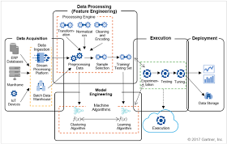

The main issue is about the fact that these high tech [robots](https://aithority.com/category/robots/) will actually replace the creator? Although these high tech computers are not good enough at some ideas and you have to rely on Human Intelligence for that. However, these can be used to save a lot of time by doing some time-consuming tasks, and we can utilize that time in creating some other designs.

Artificial Intelligence is a high technology mechanical system that can perform any task but needs a few human efforts like visual interpretation or design-making etc. AI works and gives the best results possible by analyzing tons of data, and that’s how it can excel in architecture.